**Overall Equipment Effectiveness (OEE) - Manufacturing Sector**

GOKULNATH K & E24755

**Overview**

Overall Equipment Effectiveness (OEE) is a critical KPI in the manufacturing sector that measures the efficiency of equipment by analyzing availability, performance, and quality. It helps identify areas of downtime, reduced speed, and defective production. Analyzing OEE enables manufacturers to optimize productivity, minimize equipment failures, and improve overall output. A high OEE score is crucial for achieving operational excellence and maximizing profitability.

**Objective**

1. Maximize equipment utilization by reducing downtime and breakdowns.
2. Improve production efficiency by detecting and eliminating bottlenecks.
3. Enhance product quality by minimizing defects and waste.
4. Drive continuous improvement by benchmarking performance and setting targets.
5. Reduce operating costs by optimizing availability, performance, and quality.
6. Support predictive maintenance through OEE data analysis.
7. Optimize resource allocation by aligning machinery, materials, and workforce.
8. Increase profitability by boosting overall equipment productivity and efficiency.

**Assigned Task(s)**

* Overall Equipment Effectiveness (OEE) - Manufacturing Sector

**Task Details**

* **Task 21:** Overall Equipment Effectiveness (OEE) in the manufacturing sector measures how efficiently equipment is utilized by evaluating availability, performance, and quality. It helps identify areas for improvement, optimizing production processes and reducing downtime, defects, and inefficiencies.
* **Status:** Completed.
* **Details:**
* **Analyze Dataset:** Analyze a dataset for 50 machines with planned production time, operating time, ideal cycle time, total units, and good units.
* **Availability Calculation:** Computed as the ratio of Operating Time to Planned Production Time.
* **Performance Calculation:** Calculated based on ideal cycle time relative to actual operating time and total units produced.
* **Quality Calculation:** Determined as the ratio of Good Units to Total Units Produced.
* **OEE Calculation:** Combined Availability, Performance, and Quality metrics to assess overall equipment effectiveness.
* **Data Visualization:** Used histograms with KDE to visualize distributions of Availability, Performance, Quality, and OEE.
* **Tools Used:** Employed NumPy, Pandas, Matplotlib, and Seaborn for data generation, calculation, and visualization.

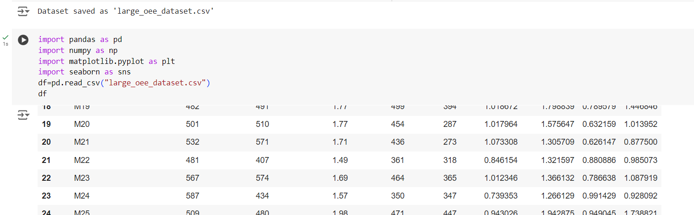

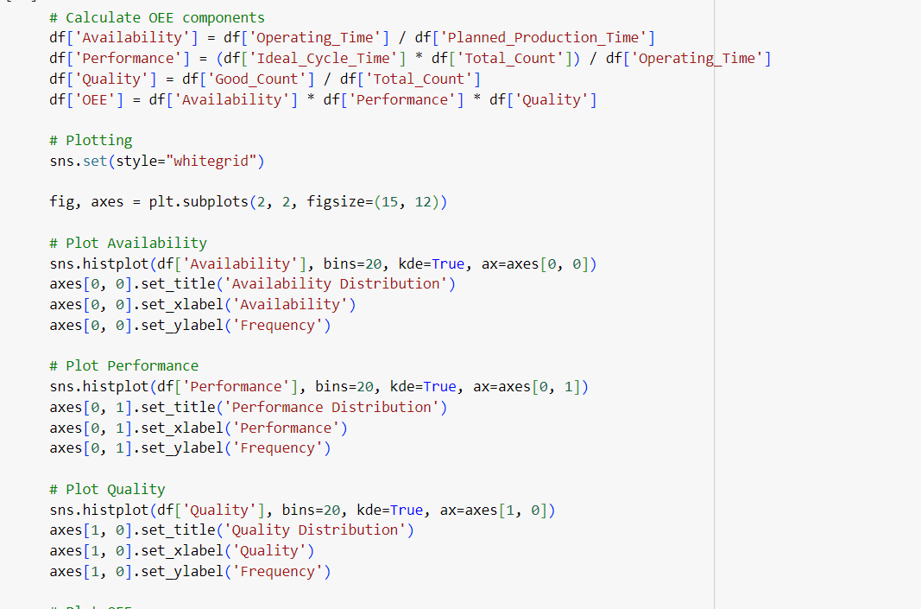

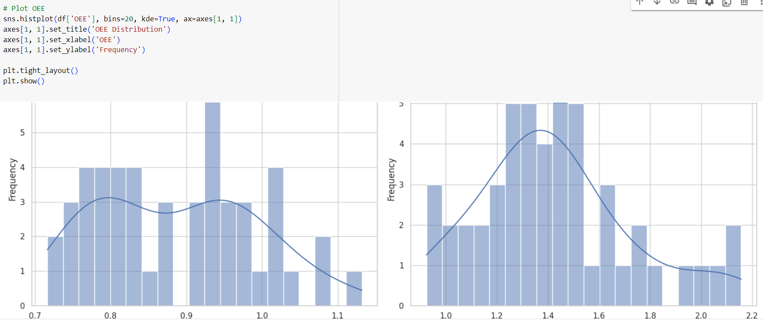

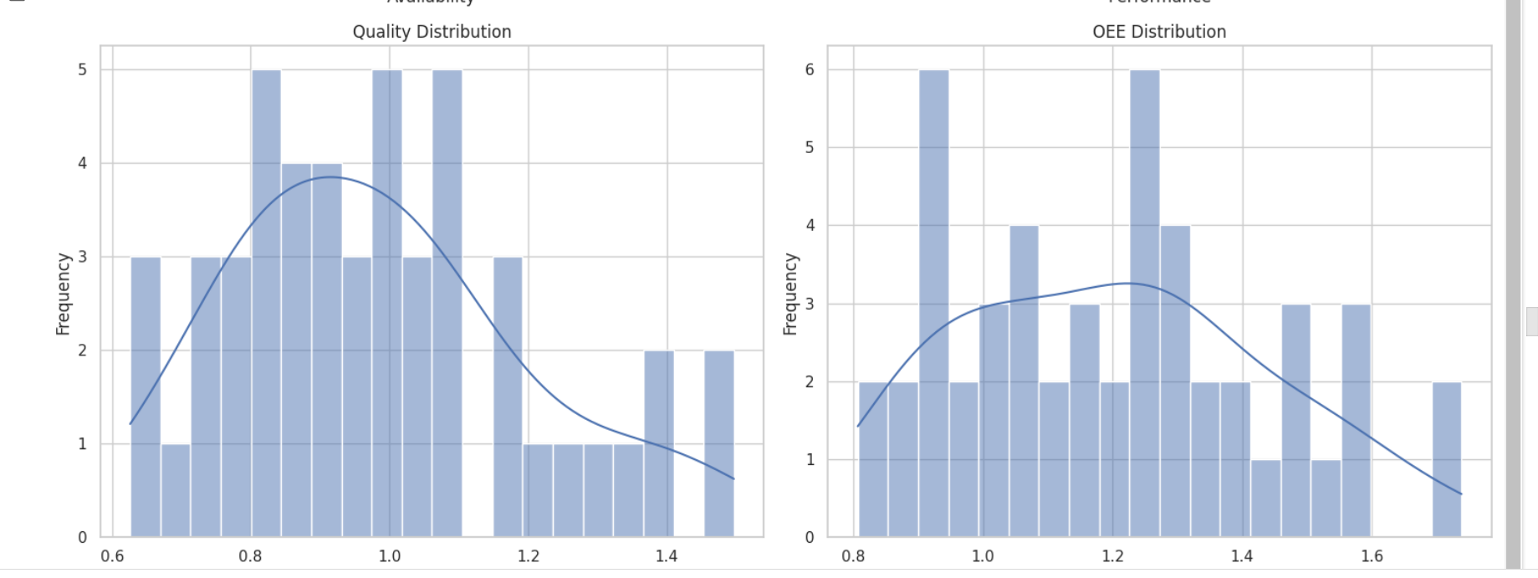

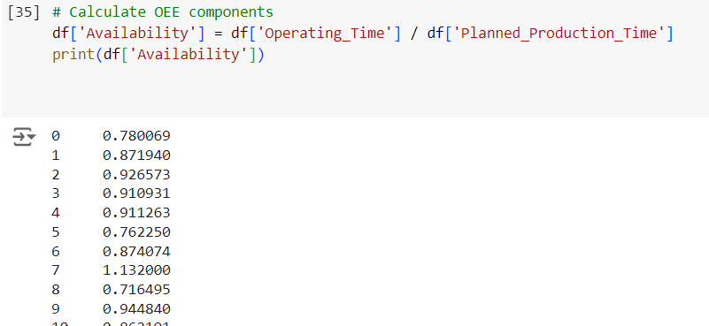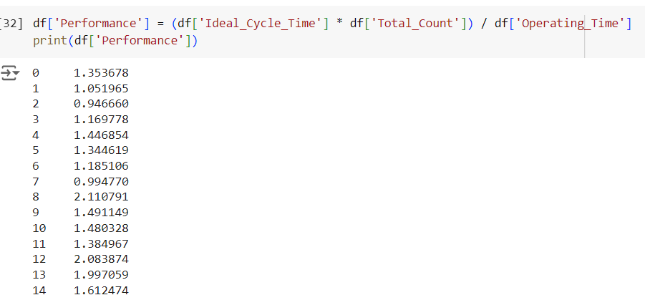

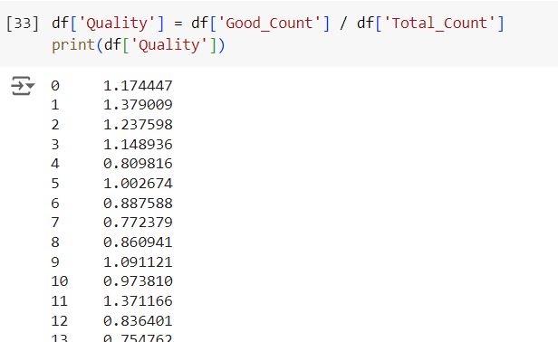

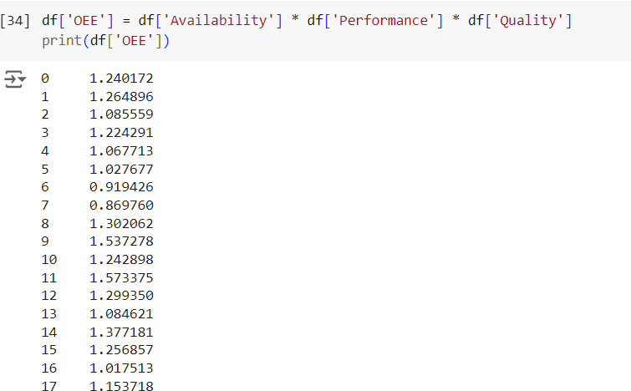

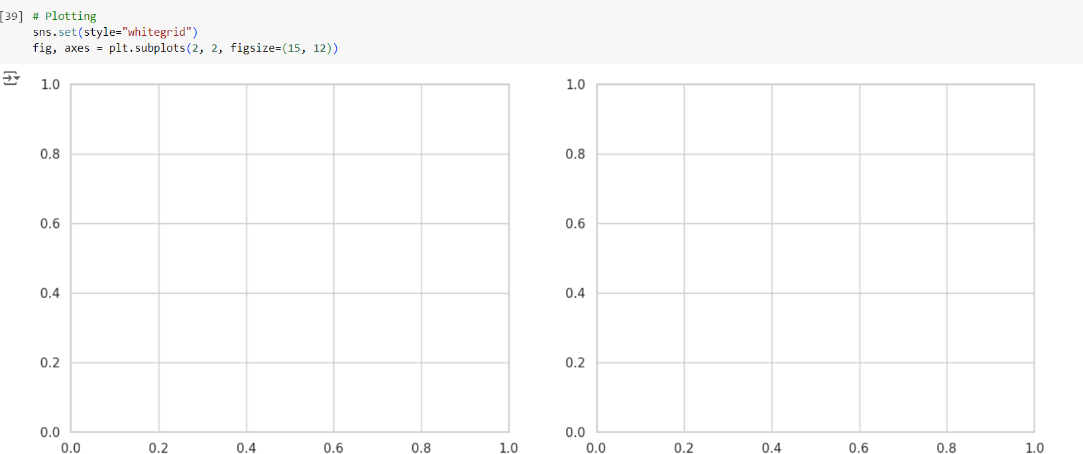

**Progress**

* **Accomplishments:**

1. Analyze Dataset: Analyze dataset with 50 machines and key production metrics.
2. OEE Calculation: Accurately computed Availability, Performance, Quality, and OEE.
3. Data Visualization: Created histograms with KDE to effectively visualize OEE distributions.
4. Insightful Analysis: Identified trends and variations in machine performance.
5. Tool Expertise: Utilized NumPy, Pandas, Matplotlib, and Seaborn proficiently.
6. Operational Impact: Provided actionable insights to enhance machine efficiency and product quality.

* **Metrics:**

1. Availability: Measures the proportion of actual operating time relative to the planned production time.
2. Performance: Assesses the efficiency of production based on the ratio of ideal cycle time to actual operating time.
3. Quality: Represents the percentage of good units produced out of the total units produced.
4. OEE: Combines Availability, Performance, and Quality to provide an overall measure of equipment effectiveness.
5. Visualization: Histograms with KDE visualized the distribution of Availability, Performance, Quality, and OEE, highlighting variations and trends.

**Challenges and Solutions**

* **Challenges Faced:**

1. Inconsistent or missing data in production logs.
2. Variability in machine performance metrics.
3. Difficulty in interpreting OEE metrics for decision-making.
4. Large dataset leading to slow computations.
5. Lack of real-time OEE monitoring.

* **Solutions Implemented:**

1. Implement data cleaning and preprocessing techniques in Pandas to handle missing values and standardize data formats.
2. Use statistical analysis and visualizations like histograms to identify patterns, outliers, and areas requiring improvement.
3. Visualize OEE components (Availability, Performance, Quality) to provide clear insights and actionable areas for process optimization.
4. Use optimized libraries like NumPy and Pandas to efficiently handle large datasets and perform vectorized calculations.
5. Integrate real-time data sources and automate OEE calculations for continuous monitoring and improvement tracking.

**Next Steps**

* **Upcoming Tasks:** Continuously improving data-driven decision-making through advanced analytics, real-time monitoring, and automation for optimized production efficiency.
* **Goals:** Adopting innovative technologies, improving data analytics capabilities, and continuously refining processes to maximize operational efficiency and competitiveness.

**Conclusion**

* **Summary:** In conclusion, optimizing Overall Equipment Effectiveness (OEE) through data analysis and visualization enhances operational efficiency, reduces downtime, and improves product quality in manufacturing.
* **Acknowledgments:** Thank you all for your time and attention. I appreciate your engagement and look forward to any questions or further discussions on this topic.